Name: |  | Class:
Instructions.
Fill in all your answers on this worksheet. You may be asked to hand it up at the end of the lesson. If you are not sure of your answers, ask your classmates first, then only approach your lecturer.

- Vectors and scalars

A ______________ is a quantity that has magnitude.
A ______________ is a quantity that has magnitude and direction.

Identify the vectors and scalars in the following list.
Temperature | Height | Velocity | Mass | Acceleration
Distance | Weight | Force | Speed | Time

- Trigonometry.

For the triangle shown, write down all the possible formulae associated with it.
Hint: what does TOA CAH SOH help you to remember?
A
B
C
θ

For the following right-angled triangles, determine their unknown lengths.

6 cm
4.5 cm

25º
60º

- Adding vectors (one dimension)

In our course, we take the right/upwards to mean the positive direction, hence our negative direction would be _______________.
Note that you can choose your own sign convention too, as long as you apply it consistently in solving the problem.
b
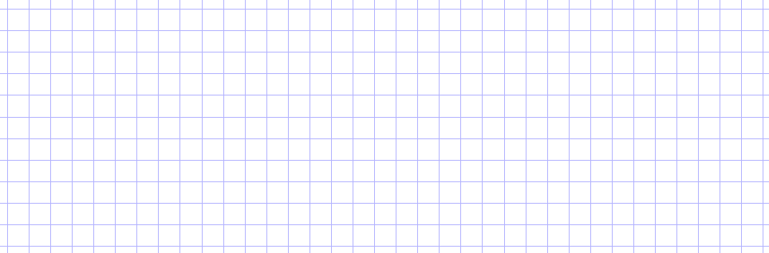
a+b gives
Vectors in
same direction
a
b
a
a+b gives
Vectors in opposite direction

The vectors a and b are shown below. In the space below each part, draw the vector sum a+b.
(a)
(b)
(c)
a
a
b
b
b
a

Does a + b give you the same result as b + a?

- Adding vectors (two dimensions)
Step 1. Move b parallel to itself, such that you can join the tail end of vector b with the head of vector a.
Step 2. a + b is obtained by connecting the points as shown.
a
b
a
b
a
b
Problem. You are given two vectors,
a and b. Find a + b.
a+b

Now, what if you are asked to find b + a?
Step 1. Move a parallel to itself, such that you can join the tail end of vector a with the head of vector b.
Step 2. b + a is obtained by connecting the points as shown.
a
b
b+a
a
b

What do you notice about b + a and a + b?
Section 4 continued. The vectors a and b are shown below. In the space below each part, draw the vector sum a+b.
(a)
(b)
(c)
a
a
b
b
b
a

- Column Vectors.

A column vector describes how a vector is to be drawn. For example, the column vector p 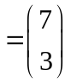 tells us that the vector p is _________ units long in the x-direction and _________ units long in the y-direction.

If you draw the column vector starting from the origin, the column vector also tells you the coordinates of the ending point of the vector. For example, the column vector
p , when drawn from the origin, will end at the point ________________ .

You are given that a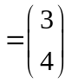, b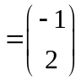 and c 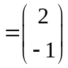. On the grid below, draw the vectors a, b and c.
y
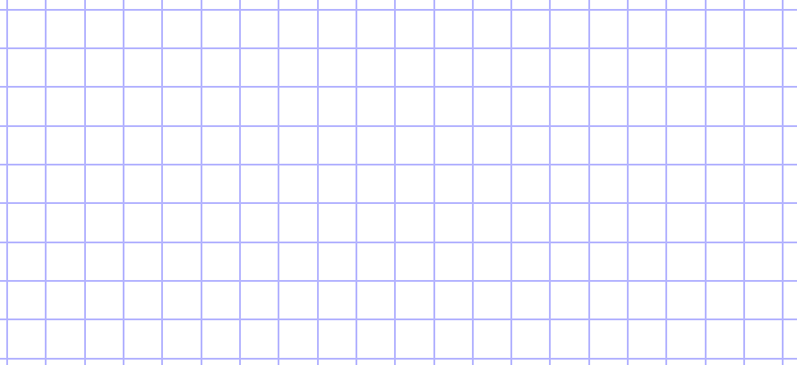
x

- Resolving a vector.
The process of expressing vectors into their components is called resolving a vector.
In the space below, write the column vector for each of the following vectors, and indicate their x-components and y-components on the diagram.

a
b
c
f
g
h
x
y

Column vectors:

a = b = c =

f = g = h =

How are vectors a and g related?

- Subtracting vectors

Given a vector a, -a reverses the direction of the vector, just like how vectors a and g in Section 6 are related. By the rules of algebra, a – b = a + (-b).
Step 2. a - b is obtained by connecting the points as shown.
a
a
a

a-b
-b
-b
b
Step 1. Reverse the direction of vector b.
You are now ready to perform a + (-b)
Problem. You are given two vectors,
a and b. Find a - b.

- Adding and Subtracting column vectors.
Using the vectors in Section 6,
  - draw the resultant vectors together with the individual vectors.
  - Write the resulting column vector.

(a) a + c
(b) h + g
(c) f - c
a
c
a+c

- Magnitude and direction of a vector

The ____________ of a vector is the length of the arrow.
The ____________ of a vector is usually specified by taking the angle of the vector with respect to the positive x-axis.
Problem. Find the magnitude and direction of the vector.
Magnitude. Draw a right-angle triangle and use Pythagoras’ theorem.
Direction. With the same right-angle triangle, you can use sine, cosine or tangent.

Find the magnitude and direction of vectors a, b and c in section 6.

- Vector components from magnitude and direction.
45º
4
y
x
45º
4
y
x
45º
4
y
x

Problem. Write the column vector given the magnitude and direction.
Step 1. Draw a right-angle triangle.
Step 2. You are ready to use sine or cosine to find the length of each side.

For the following vectors, find their x-components and y-components.
  - label them on the diagrams below. Be sure to include any negative signs.
  - Write the column vector for each.
45º
8
x
y
60º
10
y
y

x
5
x
30º

- The x and y components of velocity of a particle are 25 m/s and 60 m/s respectively. Find the magnitude and direction of the velocity vector.
[65 m/s, 67.4º with positive x-axis]

- Find the resultant of two forces of 10 N and 20 N acting at a point such that the angle between the forces is a)60º b)30º. You can measure the angle of the resultant force with respect to the 10 N force.
[26.4 N, 40.9º, 29.1 N, 20.1º]

- A car changes its velocity from 30 m s⁻¹ due East to 25 m s⁻¹ due South. Draw a vector diagram to show the initial, final and change of velocity of the car.

- Use vector components to find the magnitude and direction of the vector needed to balance two vectors shown in figure. Let the 625 N vector be along the –y axis and let the +x axis be perpendicular to it toward the right.
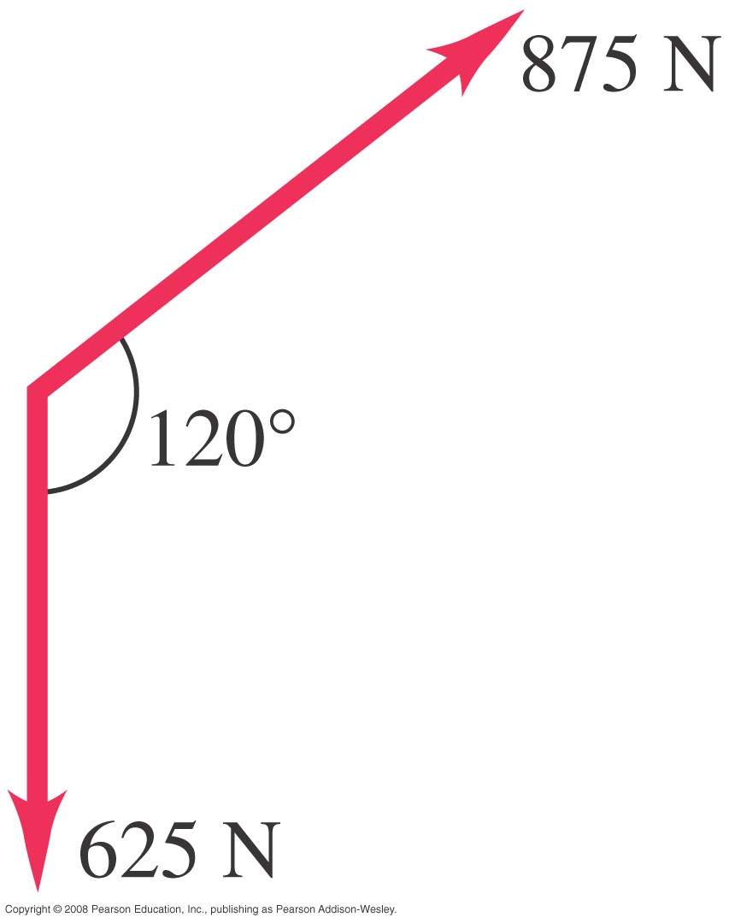
[781 N, 166.1º from +x axis]

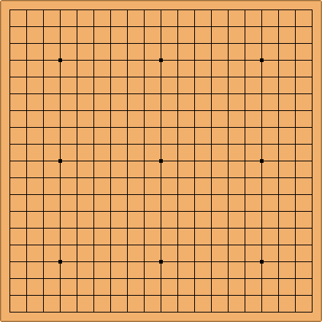
- The game of “Go” is played on a board with 19 × 19 intersections, as shown in the figure below. Black and white pieces are used in the game.
A child, not knowing the rules of the game, is playing with the Go board. She places one black piece and one white piece on the board and makes them move in the path show.
y

For each piece, write the vector for the starting position and the ending position.
Hence or otherwise, determine the change of displacement vector.
x
Does the actual path moved by the piece matter?

